COMP 3008: Human-Computer Interaction

Assignment 2

**Ryan Lo (101117765)**

**Grading**: Score out of 100 (Question 1: 25 points, 2: 70 points, 3: 5 points)

**Due date**: Wednesday, October 5 at 5 pm on Brightspace

**Lectures covered**: 4-7

**Format:** Please use Times New Roman size 12 font and normal margins

**Submission**: Submit a PDF with your name in the following format: “Lastname_Firstname_A2” **Plagiarism warning**: this assignment is to be done individually (although you may observe or interview other students in class)

# Preface

For this assignment, you can choose to work on *any interface you like*. It could be a website or software, or any other type of interface you may be interacting with (car dashboard, ATM, treadmill display, parking meter, etc.), as long as:

* It must have at least one screen (something like a TV remote would not work)
* It can be used and understood by most university students (i.e., it does not require any specialized training)
* You must have access to this interface (obviously, do not pick something that you cannot use or that is difficult to access)

In general, it helps if you pick an interface that you think is poorly designed. You also might want to consider whether you are comfortable observing someone using this interface in person. If not, it would be best if you pick a website or software. You can use this interface for all your remaining assignments and potentially for your project. You could also choose to work on a different interface each time, depending on what is most practical for you. However, it can be beneficial to work on the same interface and incrementally build on the knowledge gained from each assignment. If you have trouble choosing one, drop by office hours to discuss further!

# Software needed

For this assignment, you will need to work with [NVivo](https://www.qsrinternational.com/nvivo-qualitative-data-analysis-software/home) for your qualitative analysis. You can find all the instructions needed to get the license key [here.](https://library.carleton.ca/services/nvivo) For transcribing data, you can check out the [MacOdrum library’s options](https://library.carleton.ca/guides/subject/qualitative-research-transcription-help), use a trial version of software like [Trint](https://trint.com/), or do it manually.

**Question 1** *25 points | 5 points per part | Lectures 4, 5*

1. What **interface** have you selected? Provide a picture/screenshot and explain why you chose it (e.g., it is of special interest to you, it is particularly frustrating to use, etc.).

The interface that I have selected is the car dashboard. The reason I chose this interface is because it is well used for many drivers and something that I use every day. Sometimes it’s frustrating to use and sometimes it’s really convenient. It depends on how familiar you are to the interface as well as how often you’d use it.

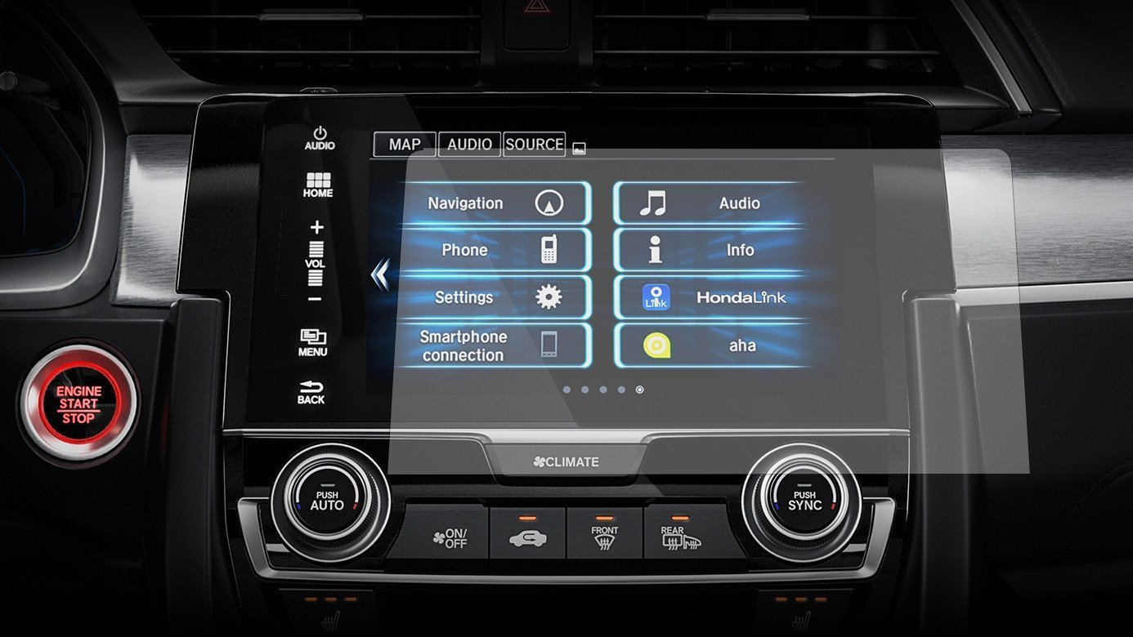

1. What visual information in your interface might be changed to a different modality to facilitate divided attention? Use **multiple resource theory** to explain your answer, clearly indicating what is being done concurrently.

A visual information that might be changed to a different modality to facilitate divided attention would have to be touch/haptic feedback for sure. When a software button is pressed on the car dashboard no audio or tactile feedback is given, only visual feedback is given when pressed. When you are driving, looking at the road and need to change something urgent on the car dashboard, according to the multiple resource theory, both visually looking at the road and looking at the car dashboard fall into the same category which makes it hard. Allowing tactile feedback falls into a different category which allows doing both looking at the road and navigating through the car dashboard concurrently easier.

1. Would you say that using this interface requires mainly **skill**, **rule**, or **knowledge-based**

behavior? Explain and give an example (make any assumptions that you need).

I would say that using this interface requires mainly skill behavior. I would assume that people have been using mobile phones, tablets and touchscreens quite often. Therefore, I would say that it is mainly a skill behavior as it is something you’d do on a regular basis.

1. Think of a type of **error** or mistake that a user might make with this interface.
   1. Describe that error/mistake and classify it using the GEMS framework

A mistake that a user might make with this interface could be picking the wrong destination. An example of this would be navigating to home instead of to school. This would be an example of perceptual confusion.

* 1. Use one or more design concepts, cognition concepts, or cognitive framework to explain how this error might have occurred

Salience could have caused this error. Having the options with same font, size, color could’ve made it hard to differentiate the options on the screen.

**Question 2** *70 points | 5 points per part | Lectures 6, 7*

For this part, you need to select one task that can be done with your interface. Pick something that has multiple steps and that takes around 20-60 sec. You can do the observations and interviews in person or online. Participants would ideally be friends/family, but they could also be students in the class (any participant should consent but no need for a formal document)

1. Clearly state the **task** that you will be focusing on (be specific)

Connecting the phone to the car, accessing android auto on the car dashboard, open a navigation application and navigate to school.

1. As a first step, you want to **observe** two people performing the selected task on your interface using the **think aloud** protocol. You will need to submit:
   1. The goal(s) of your observations; be clear and specific

The goal of my observation is to see how accessible this interface is to users. To see if the interface is easy to use or not. Also, whether it can be improved or not.

* 1. Your detailed description of the materials/techniques and approach (online/in- person) used in your observations, with justification for any decisions you took

In my observations, I asked the users to do the task as well as to explain what they are doing and thinking while doing the task. I used video recording so that I can look back to how the user interacted with the interface as well as keeping it as a record, so I don’t forget. Also took notes while the user is doing the task so I can retain mine and the users’ train of thoughts at the moment of time.

* 1. The transcripts from the think aloud protocol for both participants

User 1:

“Alright, android auto, and we open up maps. And we search for Carleton university. Here, right here. Ah, it’s going to take us 13 minutes to get to school. That’s it.”

User 2:

“Well obviously first thing we’re going to do is just hit android auto. So, I can see that waze is the first thing, I mean I could find maps but like I’m just going to hit waze cause it’s you know good enough. I’ll hit search and then I’ll type in Carleton till it pops up, there we go. The campus. And then I’ll hit go.”

* 1. Your observation notes, following the AEIOU framework

Activities: user had trouble looking for the start navigation button

Environments: lighting of surrounding was bright

Interactions: user taps on virtual buttons to open applications

Objects: user plugged into phone to connect to car dashboard, user taps on car dashboard to navigate

Users: user uses one finger to navigate

* 1. What key insights you learned, tying those back to your observation goals

User interacts with car dashboard much like interacting with any screen. Interface is easy to use and pretty straightforward as to where to click and go.

1. You decide to carry out follow-up **interviews** with your two users. Please submit:
   1. The goal(s) of your interviews (these may or may not be similar to bi.)

The goal of my interview is to see how the user experience was. If it was frustrating at all to use or not.

* 1. The interview structure, approach, and recording method, with justification

The interview was semi-structured both closed and open-ended question. Recording method was audio recorded.

* 1. The interview questions (between 4 and 7)

Have you used a car dashboard before? How about android auto or apply carplay in particular?

Anything you found hard to use?

What would you improve?

How was your experience with the software?

Were there any issues using it?

What do you think about the navigation app?

* 1. The full transcribed responses for both users

User 1:

Have you used a car dashboard before? How about android auto or apply carplay in particular?

“Yes, but never used android auto/apple carplay before.”

Anything you found hard to use?

“Hard to start the navigation, don’t know which button to press.”

What would you improve?

“Add a voice command to start navigation, please press button below.“

How was your experience with the software?

“It was alright. Never liked google’s (google map’s) colour scheme, hard to know where to press.”

Were there any issues using it?

“No issues with it.”

What do you think about the navigation app?

“It was fast, lots of results for destination especially when looking for something like a parking lot.”

User 2:

Have you used a car dashboard before? How about android auto or apple carplay in particular?

Yes, I have used android auto before not the apple one.

Anything you found hard to use?

No really, I find they are a bit unresponsive sometimes but it’s fine.

What would you improve?

I don’t think there’d be anything easy to improve, I think it’s fine as it is.

How was your experience with the software?

It’s definitely made so that anyone could use it pretty easily and really functional, overall good solid.

Were there any issues using it?

Well, not really. Like I said touchscreen and responsiveness leaves room for improvement but it’s generally find.

What do you think about the navigation app?

It works pretty well, calculates the route easily, usually have good options, it gives addictive warning, and generally pretty good.

1. Perform deductive **thematic analysis** on the interview data using NVivo. Please submit:
   1. A word cloud with logical settings of your choice

* 1. Your selected codes (select 2-4), with justification for why you chose them

Visually unclear – I chose this code because sometimes it’s too simple that you don’t know where to click

More features and improvements– I chose this code because there can be lots of potential for improvement

* 1. The results of your coding approach (pasted or screenshots)

* 1. What key insights you learned from analyzing these interviews, tying those back to your interview goals

Some things that I learned from analyzing these interviews is that sometimes they make it too simple that people think it could be something more complex which makes it hard for them to use the interface.

**Question 3** *5 points; Lectures 4-7*

**Reflect** on what you have done in this assignment. To help you think, consider the questions provided below. Your answer should be one or two insightful paragraphs and you need to elaborate on at least *two* of these questions.

* This was essentially a pilot study; what would you have done differently if you were doing a full study in real life and had more time and options?
* How would you have analyzed the transcribed data from the think aloud protocol?
* What additional analysis would you have done in NVivo to study your results?
* What techniques to understand the user and context did you find to be useful and which did not add value in this context?
* Were the SRK and GEMS frameworks useful in this context or did they not add significant value?
* Did your observations and/or interviews match any of your answers or expectations from Question 1?
* What did you learn from this assignment that you had not realized from class?

Were the SRK and GEMS frameworks useful in this context or did they not add significant value?

I think that the SRK and GEMS frameworks were useful in this context. The SRK framework gave me some insight as to depending on how often people use a touchscreen device like a mobile phone these days interact with a touchscreen car dashboard. If the car dashboard was in fact not a touchscreen I feel as though users would have to learn how it works before actually being able to use the interface. In terms of GEMS framework, it helped me categorize the different errors that would arise when using this interface.

Did your observations and/or interviews match any of your answers or expectations from Question 1?

Most of my answers or expectations from Question 1 matched my observations and interview results. I figured that people these days having used mobile phones with touchscreen now very often, even if they haven’t used a car dashboard with a touchscreen navigation, it was really easy for them to pick it up and know what to do.